Dickey-Fuller Test Result ARIMA

In ARIMA time series forecasting model, we need to first make the series stationary as the model cannot forecast on non stationary data. To make the data stationary, we would require differencing which is a method used for removing the dependence of series on time. It helps in stabilizing the mean of the time series data by eliminating factors containing trends or seasonality in the data.

Time series are stationary if they do not contain trend or seasonality in the data. (Stationary time series is usually easier to model.)

Below image, shows the result before differencing:

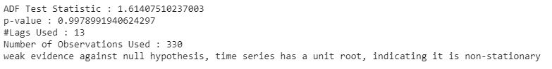

We have considered that if ‘p-value’ is less than equals 0.05 then the data is stationary else it is non-stationary.

Result after first differencing:

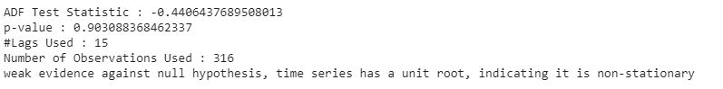

Below image, shows the results after second differencing:

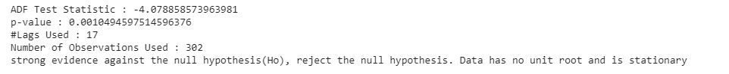

So, after second differencing the data is stationary.

3. <https://link.springer.com/article/10.1007/s10614-019-09908-9>

(please check if we have included this paper or not)

[1] XINKAI HUANG in his paper, ‘FORECASTING THE US UNEMPLOYMENT RATE WITH JOB OPENINGS INDEX’ used ARIMA time series model for predicting the unemployment rate in US based on the data containing job openings. [2] Phi-Hung Nguyen, Jung-Fa Tsai, Ihsan Erdem Kayral and Ming-Hua Lin in their paper,” Unemployment Rates Forecasting with Grey-Based Models in the Post-COVID-19 Period: A Case Study from Vietnam” used ARIMA and Grey Verhulst Model (GVM) for predicting unemployment rates in Vietnam . Their findings show that it can assist in making labor and economic policies of the country. [3] Claveria used ARIMA model to forecast unemployment rate in eight European countries.

[1] XINKAI HUANG (2015), ‘FORECASTING THE US UNEMPLOYMENT RATE WITH JOB OPENINGS INDEX’. [[Reference](https://digitalcommons.uri.edu/cgi/viewcontent.cgi?article=1716&context=theses)]

[2] Phi-Hung Nguyen, Jung-Fa Tsai, Ihsan Erdem Kayral and Ming-Hua Lin (2021),’Unemployment Rates Forecasting with Grey-Based Models in the Post-COVID-19 Period: A Case Study from Vietnam’. [[Reference](https://www.mdpi.com/2071-1050/13/14/7879/pdf)]

[3] Claveria (2019), ‘Forecasting the unemployment rate using the degree of agreement in consumer unemployment expectations’. [[Reference](https://labourmarketresearch.springeropen.com/articles/10.1186/s12651-019-0253-4)]